Update 22-5-2017

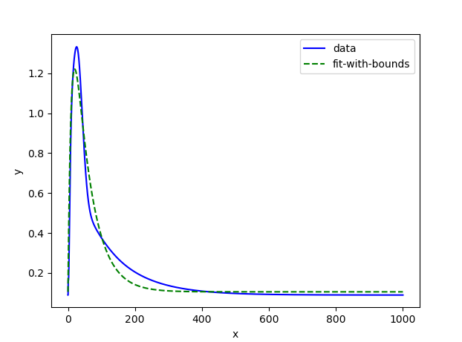

This is the fit I get for isometric Ca2+ for SL=2.3 … not great, so I was reluctant to insert this ca2+ transient into the XB model to run an isometric contraction. I figured I might not get satisfactory results.

What I DID do is take the isometric ca2+ transient from SL=1.9359 (the “widest” transient), insert it into the XB model, and run the isometric contraction protocol. The resulting bar is identical to what I get whenever I insert this fitted calcium transient into the XB model and run the WL protocol. (NOTE: the same MODELS were used for both scenarios, just different python protocols… this makes sense because the WL simply never generated enough force to overcome the afterload)



above shows isometric contraction and WL contraction (the results are identical) with fixed(fitted) ca2+ transient from a contraction performed at SL= 1.9359.

How will I figure out if the problem comes from the fitted ismetric ca2+ transient? 🡪 I have to use a fitted ca2+ transient to recreate the “normal” contraction data.



Peak force green = 12.91

Peak force red = 13.6









The colored plots show Kenneth’s isometric force transients for varying SL and the two cyan plot are what my current model produces at SL = 1.8 and SL=2.0 (note: the colors are incorrect for the Kenneth data)… Just know that the Cyan data are attempting to recreate the first and third colored transient from the bottom.



I am getting the same reaction in the old version of the model that is supposed to replicate Kenneth’s results!



cyan = F_total normalized

green = active normalized

(the discrepancy comes in because passive force component and because tmpC in this scenario is 23 when in Kenneth’s version tmpC= 22.5)🡪 See following page for correct fit



tmpC = 22.5 🡪 Yay now I am once again replicating Kenneth’s isometric results!

Now I just need to see if the sensitivity of force to the cai2+ transient exists in this version of the model…







same experiment as on previous time, tis time tmpC=30